Muhammad Ashraf Fathy Ahmed ID: 2305181
Yakoot Shaker Naseem Shaker ID: 2305557

========================
server.py
========================

import socket

HOST = '127.0.0.1'
PORT = 12345

server_socket = socket.socket(socket.AF_INET, socket.SOCK_STREAM)
server_socket.bind((HOST, PORT))
server_socket.listen(1)
print(f"Server is running on {HOST}:{PORT}")

conn, addr = server_socket.accept()
print(f"Connected by {addr}")

while True:
data = conn.recv(1024).decode()
if not data:
break

command = data[0]
text = data[1:]

if command == 'A':
result = ''.join(sorted(text, reverse=True))
elif command == 'C':
result = ''.join(sorted(text))
elif command == 'D':
result = text.upper()
else:
result = data

conn.sendall(result.encode())

conn.close()

Run in Terminal:

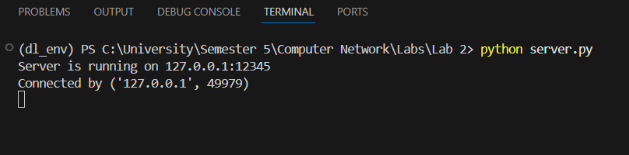

========================
client.py
========================

import socket

HOST = '127.0.0.1'
PORT = 12345

client_socket = socket.socket(socket.AF_INET, socket.SOCK_STREAM)
client_socket.connect((HOST, PORT))

print("Connected to the server. Type your message or 'exit' to quit.")

while True:
message = input("Enter message: ")
if message.lower() == 'exit':
break

client_socket.sendall(message.encode())
data = client_socket.recv(1024).decode()
print("Server reply:", data)

client_socket.close()

Run in Terminal:

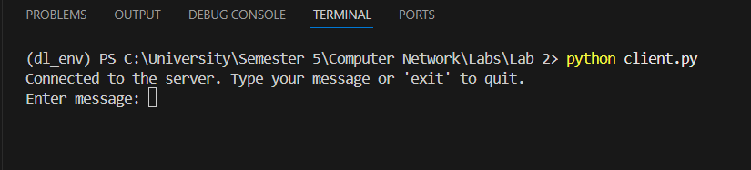

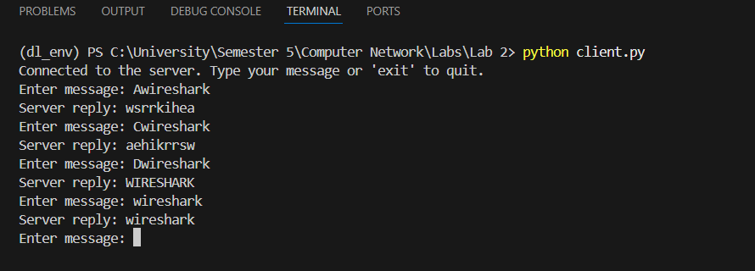

Wireshark:

Using filter tcp.port == 12345 → Shows packets that use TCP port 12345 only

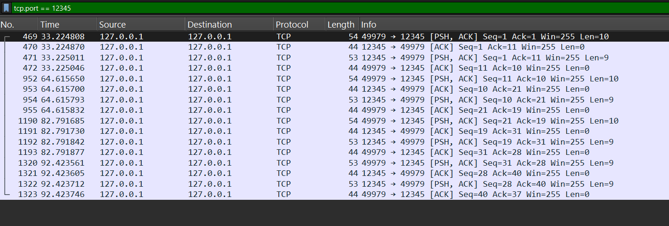

Without filtering:

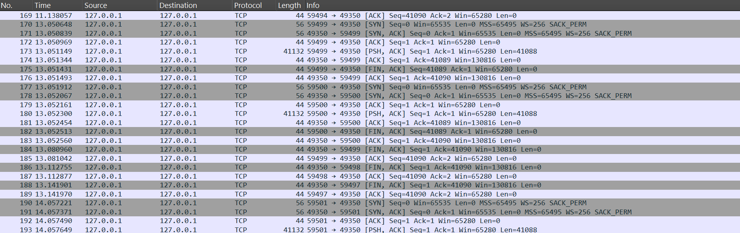

Packet Bytes Pane:
